State Management

GMAT’s state management system is shown in Figure 1. This system consists of three management classes: StateManager, the base class for all state management functionality, EstimationStateManager, the state manager that controls the estimation state vector, and PropagationStateManager, used to handle the state vector used by GMAT’s propagation subsystem. The state vector itself is an instance of the GmatState class, This class contains members that represent the epoch of the vector, the data in the vector, and attributes of these data elements. GmatState provides methods that make state vector manipulations simple for the components that need them. Finally, the PropagationStateManager uses a helper structure, ListItem, which makes state manipulations easy to manage. <TBD: is there a similar struct for the ESM? Can both managers use the same struct?> All of these classes are described in more detail in the following paragraphs.
<sph: I believe we can use a struct that is similar to the PSM for the ESM. The ESM has a few extra state management functions that go beyond the state vector itself though.>
<sph: Perhaps a simple figure would help others understand the state managers. Perhaps have a state vector on the left, with different chunks from, say, cartestian state for 2 spacecraft, and STM for one of the spacecraft. In the middle show something that represents the state manager, and on the right, have the objects themselves. Use arrows to show how the data is mapped from objects to the state vector. Not sure we need this now though. Thoughts?>

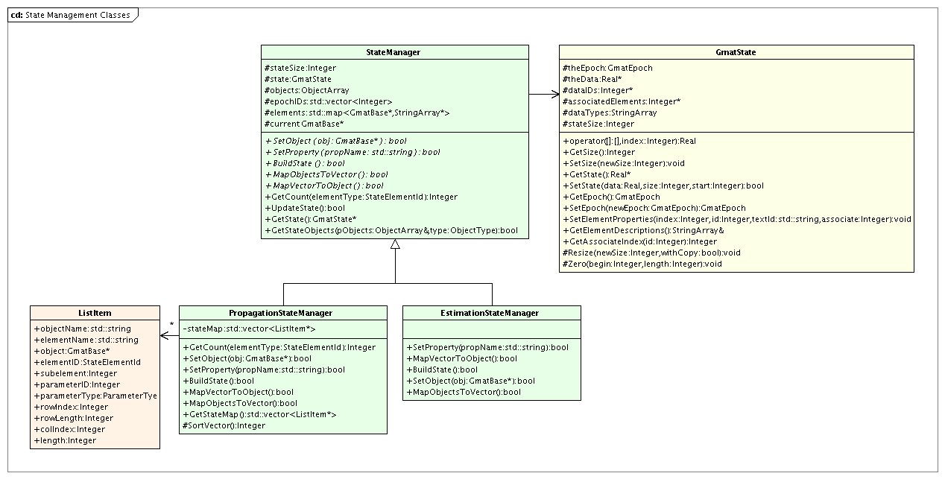
Figure 1: State Management Classes used in Propagation and Estimation

GmatState Class
State data in GMAT is contained in a core class, GmatState, designed to contain an epoch, a vector of corresponding state information at that epoch, and the interfaces necessary to work with the state data. The class provides overridden operators that facilitate element manipulations using C++’s standard array indexing syntax. It also provides the ability to associate elements with one another, simplifying computations that relate one chunk of the vector with state data in a separate chunk.

Attributes of the GmatState Class

- GmatEpoch theEpoch: The epoch associated with the state data.
- Real *theData: The state vector data.
- Integer *dataIDs: Element ID’s associated with the state vector elements.
- Integer *associatedElements: State vector index for the elements associated with the current element. This index is used to associate vector elements that are possibly distant from one another with their core components; for example, the computations of the orbit state transition matrix (STM) use this field to connect the STM to the corresponding Cartesian state elements using this index.
- StringArray dataTypes: Text descriptions of the state elements.
- Integer stateSize: The length of the state vector.

GmatState Methods

- Real& operator[](const Integer index): and
- Real operator[](const Integer index) const: Array element accessor operator overloads that enable access to the state vector element by element using square brackets.
- void SetSize(const Integer size): Resizing method used to change the state vector size.
- Integer GetSize() const: Accessor that returns the current size of the state vector.
- Real* GetState(): Accessor used to directly manipulate the state vector. This method enables direct manipulation of the internal data of the GmatState, and should only be used when performance considerations are paramount.
- bool SetState(const Real *data, const Integer size, const Integer start = 0): Sets all or part of the state data to the input data vector.
- GmatEpoch GetEpoch() const: Retrieves the state vector epoch.
- GmatEpoch SetEpoch(const GmatEpoch ep): Sets the state vector epoch.
- bool SetElementProperties(const Integer index, const Integer id, const std::string &textId, const Integer associate): Sets the properties of a state element for later use.
- const StringArray&GetElementDescriptions(): Retrieves the array that provides an element by element description of the contents of the state vector.
- Integer GetAssociateIndex(const Integer id): Retrieves the index into the state vector for elements associated with a state vector element.

StateManager Base Class

The StateManager base class defines the interfaces used for state management in GMAT. Each StateManager contains a GmatState that is manipulated to perform the associated estimation or propagation. Design of the State Manager class is based on the Mediator design pattern of Gamma et al [add ref in master doc] and promotes loose coupling among system components by using a many to one relationship instead of a many to many relationship. Using the mediator pattern for the State Managers, an Estimator, for example, does not have to communicate directly with all of the objects involved in an estimation problem, the estimator simply communicates with the ESM. The ESM and PSM coordinate state data management between the estimators and propagators. The advantage is that estimators and propagators can remain streamlined and efficient and that new state types can be easily incorporated at a later time without changes to the estimators and propagators. The trade off is that the state manager centralizes complexity and must be carefully designed for ease of maintenance. However, if designed well, the State Manager will make incorporating new objects easier.

<sph: we probably need some transition text that gives an overview of why the data and methods exist on the base SM class.>

StateManager Attributes

- Integer stateSize: Size of the GmatState vector.
- GmatState state: The GmatState managed by this manager.
- ObjectArray objects: The collection of objects that supply the state vector.
- std::vector <Integer> EpochIDs: Epoch indices for the objects, used to ensure epoch synchronization so that the state data can validate that the data all occurs at the same epoch.
- std::map<GmatBase*, StringArray> elements: Mapping between the objects and the names of the object properties that are used in the managed process.
- GmatBase *current: Pointer to the most recently accessed object, provided for convenience.

StateManager Methods

- virtual bool SetObject(GmatBase *obj) = 0: Method used to register an object with the StateManager. Derived classes must provide an implementation for this method.
- virtual bool SetProperty(std::string propName) = 0: Sets a property for the current object as a member of the process that uses this manager. Derived classes must provide an implementation for this method.
- virtual bool BuildState() = 0: Constructs the GmatState vector based on the properties that have been set on the manager. This method establishes the state vector, populates the mappings used to fill the vector, and provides the manager with an ordered vector ready for managements. Derived classes must provide an implementation for this method.
- virtual bool MapObjectsToVector() = 0: Retrieves the state data from GMAT’s objects and sets the state vector to contain the values of these data. This method is used to populate the data in the GmatState for use by the process that uses a StateManager. Derived classes must provide an implementation for this method.
- virtual bool MapVectorToObjects() = 0: Sets the data on GMAT’s objects to match the data contained in the GmatState vector. This method is used to pass data produced from the estimation or propagation process back into the code objects that need it. Derived classes must provide an implementation for this method.
- virtual Integer GetCount(Gmat::StateElementId elementType): Retrieves the number of objects that supply the specified element type to the GmatState.
- virtual bool UpdateState: Updates the state vector to incorporate changes in the data being used in the managed process. The default version of this method simply returns true; StateManager subclasses that need this functionality should override this method.
- virtual GmatState* GetState(): Retrieves the GmatState object for use outside of the Manager.
- virtual bool GetStateObjects(ObjectArray& pObjects, Gmat::ObjectType type = Gmat::UNKNOWN_OBJECT): Walks through the list of objects being managed, filling in the pObjects array with their pointers when they match the requested type. If the requested type is Gmat::UNKNOWN_OBJECT, then all of the managed objects are placed in the list.

EstimationStateManager Class

The estimator state manager is a derived class from the state manager base class and is primarily responsible for getting and setting estimation related state data on measurement participants and assembling STM and covariance matrices from the sub elements obtained from individual objects. For example, after an iteration (for Batch) or state update (for sequential), the ESM maps the new estimated state vector to the participating objects. Similarly, when an estimator needs the STM, the ESM retrieves the portions of the STM from the objects involved in estimation and assembles the complete STM, or provides appropriate sub-matrices to the Estimator.

Most of the member data and methods for the ESM are located on the SM base class. For example, the estimation state vector (ESV) is a data member of the SM base class and the methods used to manage the ESV are also located on the SM base class. However, there are data members and methods that are specific to the ESM. The data members specific to the ESM include the STM of the estimation state vector (ESV), the covariance matrix of the ESV, the vector of consider parameter, the state transition matrix of the consider parameters, and the covariance of the consider states.

In the following sections, we discuss member data and methods specific to the ESM.

Member Data

- solveForSTM: The state transition matrix of the solve for state vector. If the state vector has n components, then solveForSTM is an nxn array.
- considerSTM: The state transition matrix of the consider state vector. If the consider state vector has m components, then solveForSTM, is an mxm array.
- solveForCovariance: The covariance matrix of the solve for state vector. If the state vector has n components, then solveForCovariance, is an nxn array.
- considerCovariance: The covariance matrix of the consider state vector. If the consider state vector has n components, then considerCovariance, is an mxm array.
- considerStateVector: The vector of consider states.

< SPH: We still need to address the issue Matt raised as to how to handle STM chunks and take advantage of sparse matrix manipulations. To do this we will probably need to define new sparse matrix data types. Matt probably has the most insight here regarding what we would need for LaPack. This seems like a future modification though and not a version 1.0 feature.>

Class Methods

- Initialize: During initialization, the ESM gets pointers to all objects that have solve for states and solve-for states requested by the user, and all consider states.
- MapObjectsToSolveForSTM: This method loops over all state chunks contained in the ESV, calls the GetSTM method on the object associated with the current chunk, and places the STM chunk in the correct location in solveForSTM.
- MapObjectsToConsiderSTM: This method loops over all state chunks contained in the consider state vector, calls the GetSTM method on the object associated with the current chunk, and places the STM chunk in the correct location in considerSTM.
- MapObjectsToSolveForCovariance: This method loops over all state chunks contained in the ESV, calls the GetCovariance method on the object associated with the current chunk, and places the covariance chunk in the correct location in solveForCovariance.
- MapObjectsToConsiderCovariance: This method loops over all state chunks contained in the consider state vector, calls the GetCovariance method on the object associated with the current state chunk, and places the covariance chunk in the correct location in considerCovariance.
- MapSolveForCovarianceToObjects: This method loops over all state chunks contained in the ESV and passes the covariance matrix associated with the state chunk to the SetCovariance method on the object associated with the current chunk.

PropagationStateManager Class

